

Active Network Internal Guide

Team/Group Registration Information

ActiveNet

Document Version: 1.0

Publication Date: Jul. 5, 2012

Document Owner: Katherine Quan

FOR INTERNAL USE ONLY; NOT FOR CLIENT RELEASE.

League Business Cases and Settings

The purpose of this document is to outline the appropriate scenarios when implementing the Team Function of Activity Registration. Provided below are the settings for the module and their intended uses.

Team/Group Information Vs. League Scheduling

It is important to understand the difference between Team/Group Information and Leagues. Both functions are able to operate separately or together.

**Team/Group Information**

Team/Group Information is a subset within Activity Functions which enables team/group registration. More specifically these functions control the way customers can enroll and pay for the activity.

Groups are used to group together activity participants, and are similar to teams. The exceptions are that group captains cannot pay for group members, and groups are not used for leagues or tournaments.

**League Scheduling**

A League or Tournament is an instance within ActiveNet where team vs. team games or practices are scheduled at a facility. League configuration is not covered within this document, however it is important to note that the following user cases will allow for League configuration. In order for the League to properly secure facilities and meeting times, ensure that the Activity is not reserving facilities and does not create meeting times.

User Cases

**Scenario 1** – Team enrollment only, team captain pays activity fee(s)

**Business Case:** This is a common business practice for adult sports leagues due to its low administrative requirements. In this example the organization will take team enrollment only and require that the team captain (or other team contact) be responsible for payment. Organizations will on occasion allow the captain to utilize a payment plan while fees are collected from team members, but the captain is ultimately responsible for the balance. This prevents the organization from having to track down separate payments from individual players. It is assumed that every enrollment is a new team enrolled. Team members must be added to the team roster. This includes the individual who has paid for the team.

**Constraints:** Team rosters must be maintained outside of ActiveNet.

**Team/Group Configuration:**

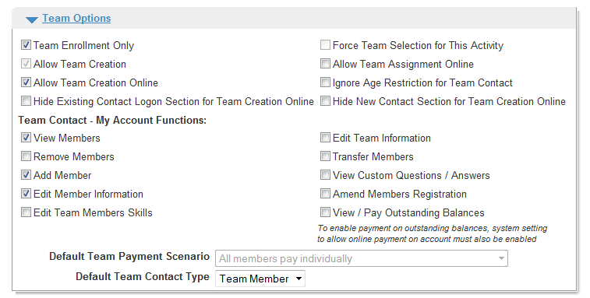

**Charge Configuration:** Set up a single fee for the full team charge. No Team Prefill Condition is required.

**Scenario 2** – Individual enrollment and payments only, teams are created by staff after registration.

**Business Case:** This is a common business practice for youth leagues. It allows individuals to register and pay on their own so that an administrator can create the teams upon completion of the registration period. This allows fairer distribution of skills/ages/members across teams.

**Constraints:** Individuals may be allowed to request teams/teammates/coaches through the use of custom questions but it is ultimately up to an administrator to assign them to a team.

**Team/Group Configuration:**

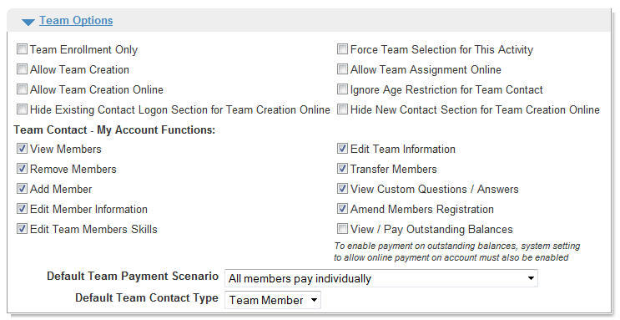

**Charge Configuration:** Set up a single free for the individual charge. No Team Prefill Condition required.

**Scenario 3** – Individuals can create a team (ex: coach), create and join a team (ex: team captain), join an existing team, or register as a free agent*. All players must pay individually. Non-playing team contacts do not pay anything.

**Business Case:** This scenario would be offered if an organization was running adult leagues but wanted to collect payment separate from each player. This setup also enables the organization to produce a detailed roster within ActiveNet as well as allow participants to agree to waivers within ActiveNet.

**Constraints:** This process requires more administrative resources than scenario 1 as it effectively forces the organization to act as a collection agency rather than the team captain. Due to the nature of recreational adult sports it is often challenging to incentivize players to register on their own so it could prove challenging to ensure all participants are registered and paid for by the registration deadline.

Since each team member pays separately, the total cost of each team is a function of the number of players per team. Therefore a team that has only 8 members will pay less than a team with 10 members. If an organization wants players to pay separately but base their fees on the number of players (Team Fee / number of player) they must use Scenario 1 and have the team captains monitor payments.

If the organization wishes to create a separate team for all free agents it will have to do a front desk enrollment with a placeholder serving as a customer.

**Team/Group Configuration:**

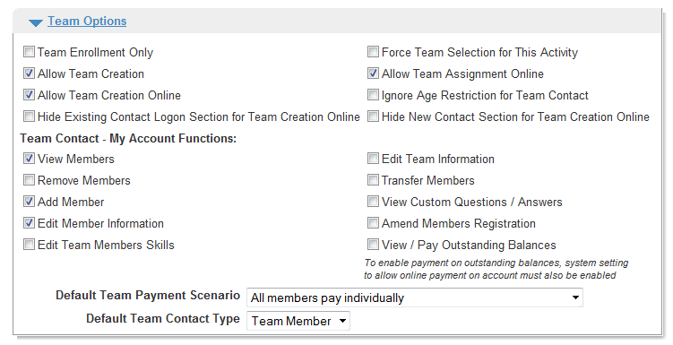

* “Force Team Selection for This Activity” will prevent free agents from registering.

**Charges Configuration:** Set up a single fee for the individual charge. No Team Prefill Condition is required.

**Scenario 4** – Individuals can create a team (ex: coach), create and join a team (ex: team captain), join an existing team, or register as a free agent*. Players are paid for in advance by team captains. Non-playing team contacts do not pay anything.

Teams created must assign secret word in order to ensure that their prepaid spots are not taken by another customer enrolling for the activity. Teams can enroll additional customers either through their My Account function, or they can have the individual register for the activity and select the appropriate team. Additional members over and above the prepaid amount will be subject to the individual fee.

**Business Case:** This scenario would be offered if an organization was running adult league, consolidated payment, but also wanted to collect all participant data. This setup enables the organization to produce a detailed roster within ActiveNet as well as allow participants to agree to waivers within ActiveNet. This set up allows team to charge per player. The total cost of the team is determined by the number of players on the team.

**Constraints:** This process requires more administrative resources than scenario 1 due to the requirement that all participants register separately. Due to the nature of recreational adult sports it is often challenging to incentivize players to register on their own so it could prove challenging to ensure all participants are registered and paid for by the registration deadline. Also, the prepayer of the team must is not enrolled during team creation. Teams will need to be sure to enroll the prepayer into the team.

If the organization wishes to create a separate team for all free agents it will have to do a front desk enrollment with a placeholder serving as a customer.

Suggested Team/Group Configuration:

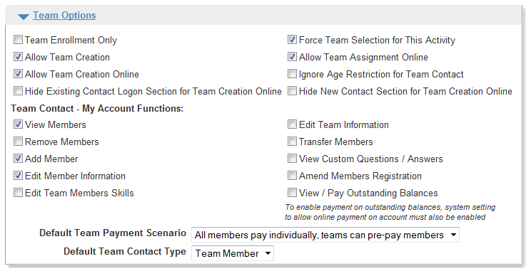

**Charges Configuration**: Set up a single fee for the individual charge. No Team Prefill Condition is required.

**Scenario 5 –** Default Team Payment Scenario Lump sum where team is same price regardless of player; ability to register roster into system

**Business Case**: This scenario is similar to that of scenario 4, however instead of the team fee being determined by the number of players on the team, this scenario has a set team fee regardless of the number of players. All participant information is collected.

**Constraints**: This scenario has the same constraints as scenario 4. In addition, this set up does not offer the option for free agent enrollment through Front Desk. All participants will have to create and or select a team.

Suggested Team/Group Configuration

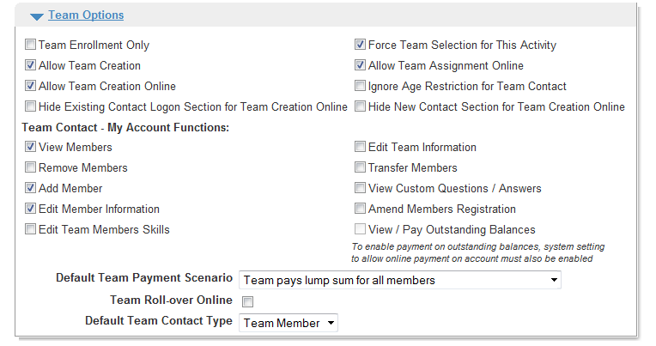

**Charges Configuration:** Set up a single fee for the individual charge. No Team Prefill Condition is required.

**General Team Configuration Tips**

* If you will be using the Team configuration for League Scheduling, do not use Parent Activity and Sub Activity functions when creating Activities
* Setting the ‘Default Team Payment Scenario’ to ‘Team pays lump sum for all members’ will disable the option to create additional teams through the Manage Teams function on Front Desk
* In order to generate a league schedule in the League Scheduling module, your activity must be populated with teams
* If you do not see ‘Team/Group Configuration’ options in your Activity Function page, ensure that you have this option checked in your Activity Type.
* If you’re User Scenario has multiple divisions for one league, opt to create an Activity for each division. The ‘Manage Divisions’ function under ‘Team/Group Configuration’ does not allow you to schedule separate divisions in the League Scheduling